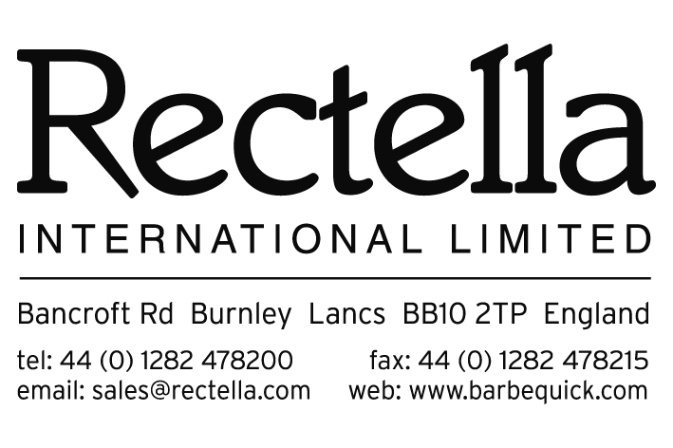
COMPANY / SUPPLIER NAME:

QA5(d)R TECHNICAL STANDARDS and QUALITY SYSTEMS
Rectella International Ltd also have a policy to use only suppliers who can demonstrate that they work to high standards and have in place an effective quality management system. We also expect our suppliers to monitor the quality management systems of their supply chain for our goods. – Please see Section 2, page 5 ‘Technical Standards and Quality Systems’ within our Supplier Manual for full statement and requirements.
 | Yes | No | N/A | Rectella Use (Managing Risk) | Rectella Use  (At Risk)
- Are you approved to BS EN ISO9001:2008 or BRC
Consumer Products?

If yes, please enclose a copy of certification and proceed to the compliance declaration on page 2 of this form.
If no, please see table of questions below and tick where applicable. Where the answer is ‘yes’ in the table of questions, would you please be able to provide evidence.
These questions are not exhaustive, and a standard Technical Audit would cover the points & they are for Rectella to identify if there is a risk with the supplier.
The purpose of the questions: If the supplier doesn’t have an Independent Technical Audit, the questions below & any evidence provided will help Rectella to identify if there is a risk with the supplier. Please refer to the ‘Technical Standards and Quality Systems’ page 5 in our Supplier Manual for further information.
 | Yes | No | N/A | Rectella Use (Managing Risk) | Rectella Use  (At Risk)
- RISK MANAGEMENT/ASSESSMENT SYSTEMS
  - Have you done a Product Risk Assessment on product intended to supply?
  - Do you have a Production Process Flow Chart with critical controls highlighted?
  - Have you identified which, if any of your products are safety critical? (i.e. Product which, if not manufactured correctly, represents a safety risk to the end user).
  - For Safety Critical Product have you carried out a documented Product Risk Assessment to demonstrate:
- Compliance with British or European Legislation
- Fit for intended purpose.
In the case of (a) please specify if this assessment has been carried out by:
- Externally nationally accredited laboratory / test house or
- Your own internal
- QUALITY MANAGEMENT SYSTEM
  - Do you have a documented Quality System?
  - Do you have Corrective & Preventive Action Plans in place, and controls for Non-Conforming Product?
  - Do you carry out inspection of goods against sealed samples or written specifications?
  - Do you regularly audit internally?
  - Do you audit your suppliers for their Quality Control Processes?
- PRODUCT & PROCESS CONTROL
  - Does a written specification exist for product intended to supply?
  - Do you have a procedure in place to control reference samples of pre-production and production product?
  - Do you have an inspection process in place for incoming goods, produced goods and despatching goods?
  - Do you have control of operations to ensure equipment is capable of producing safe and legal product?
  - Do you have (if necessary) a Foreign Body Detection & Control process? (i.e. Metal detection).
  - Do you have calibration records for any device or machines used in your production process?
- PRODUCT TESTING & PRODUCT CLAIMS
  - Do you have a suitable testing program to ensure products are safe and meet legal requirements?
  - Do you have returns history for products you intend to supply?
- TRAINING & COMPETENCY
  - Do you have training records for employees?

Compliance Declaration
Please sign below to declare that all products supplied to Rectella International Limited will be in compliance with:
- The General Product Safety Regulations 2005
- The Restriction of the Use of Certain Hazardous Substances (RoHS) 2006
- Waste Electrical and Electronic Equipment (WEEE) Regulations
- REACH (Registration, Evaluation, Authorisation and restriction of Chemical Regulations 2007
- Our Packaging Guideline Policy as shown in the Rectella Supplier Manual
- The Rectella Timber Regulations as shown in the Rectella Supplier Manual
I declare that I am authorised to declare on behalf of :
That all products supplied by our company to Rectella International Limited will conform to the points shown above.
Signature :
Print Name :
Title :

Signature of Supplier Representative :
Printed Name of Supplier Representative :
Date Form Signed :
******************** END of FORM 3 ********************

Documentation Fulfilled – RECTELLA USE ONLY
Documents / Information Required (COMPLETED) | Complete / Documents Received – Yes / No
- BS EN ISO9001:2008 / BRC Certification (COMPLETED & COPY ENCLOSED)
- Documented Quality System if not certified (COMPLETED & COPY ENCLOSED)
- Declaration of Compliance (COMPLETED & SIGNED)

Checked By :
Filled Date :

